Copyright Transfer Form

Title of the paper: Trends in the prevalence and association between Escherichia coli (E. coli) contamination in household drinking water and the risk of childhood diarrheal disease in Bangladesh

The authors hereby transfer all copyrights in and to the manuscript named above in all forms and media, now or hereafter, if and when the paper is accepted for publication in the Clinical Epidemiology and Global Health. The authors reserve all proprietary right other than copyright, such as patent rights.

Everyone who is listed as an author in this article should have made a substantial, direct, intellectual contribution to the work and should take public responsibility for it.

This paper contains works that have not previously published or not under consideration for publication in other journals.

Corresponding author: _____ Md Jamal Uddin_____ ____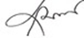___ _____15-Aug-22_____
Name Signature Date
Authors: ____Mohammad Nayeem Hasan___ _____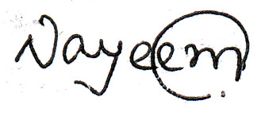_____ ______15-Aug-22______
Name Signature Date
___ Muhammad Abdul Baker Chowdhury __ ____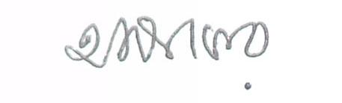___15-Aug-22_____
Name Signature Date
____ Maya Biswas_______ ________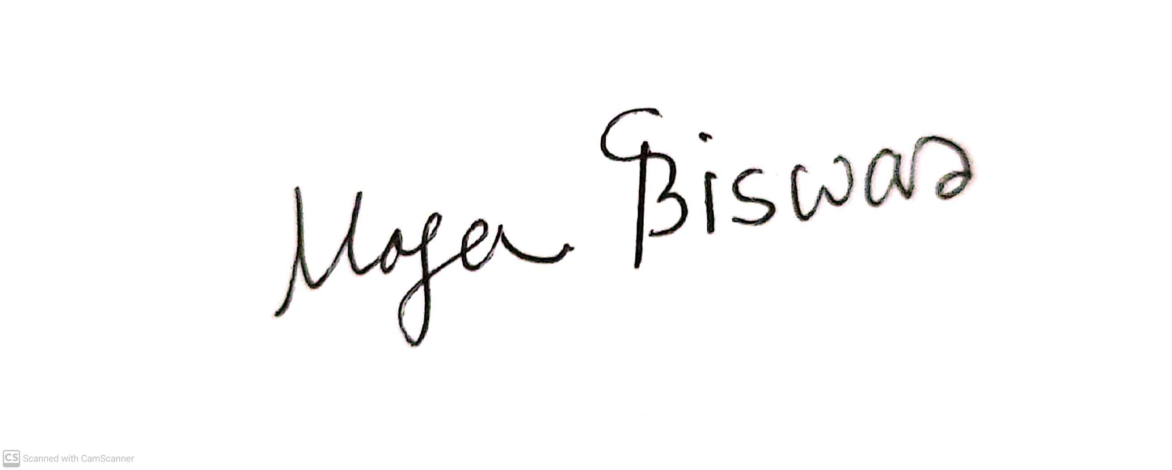_______ ______15-Aug-22____
Name Signature Date
____ Moumita Paul _______ _________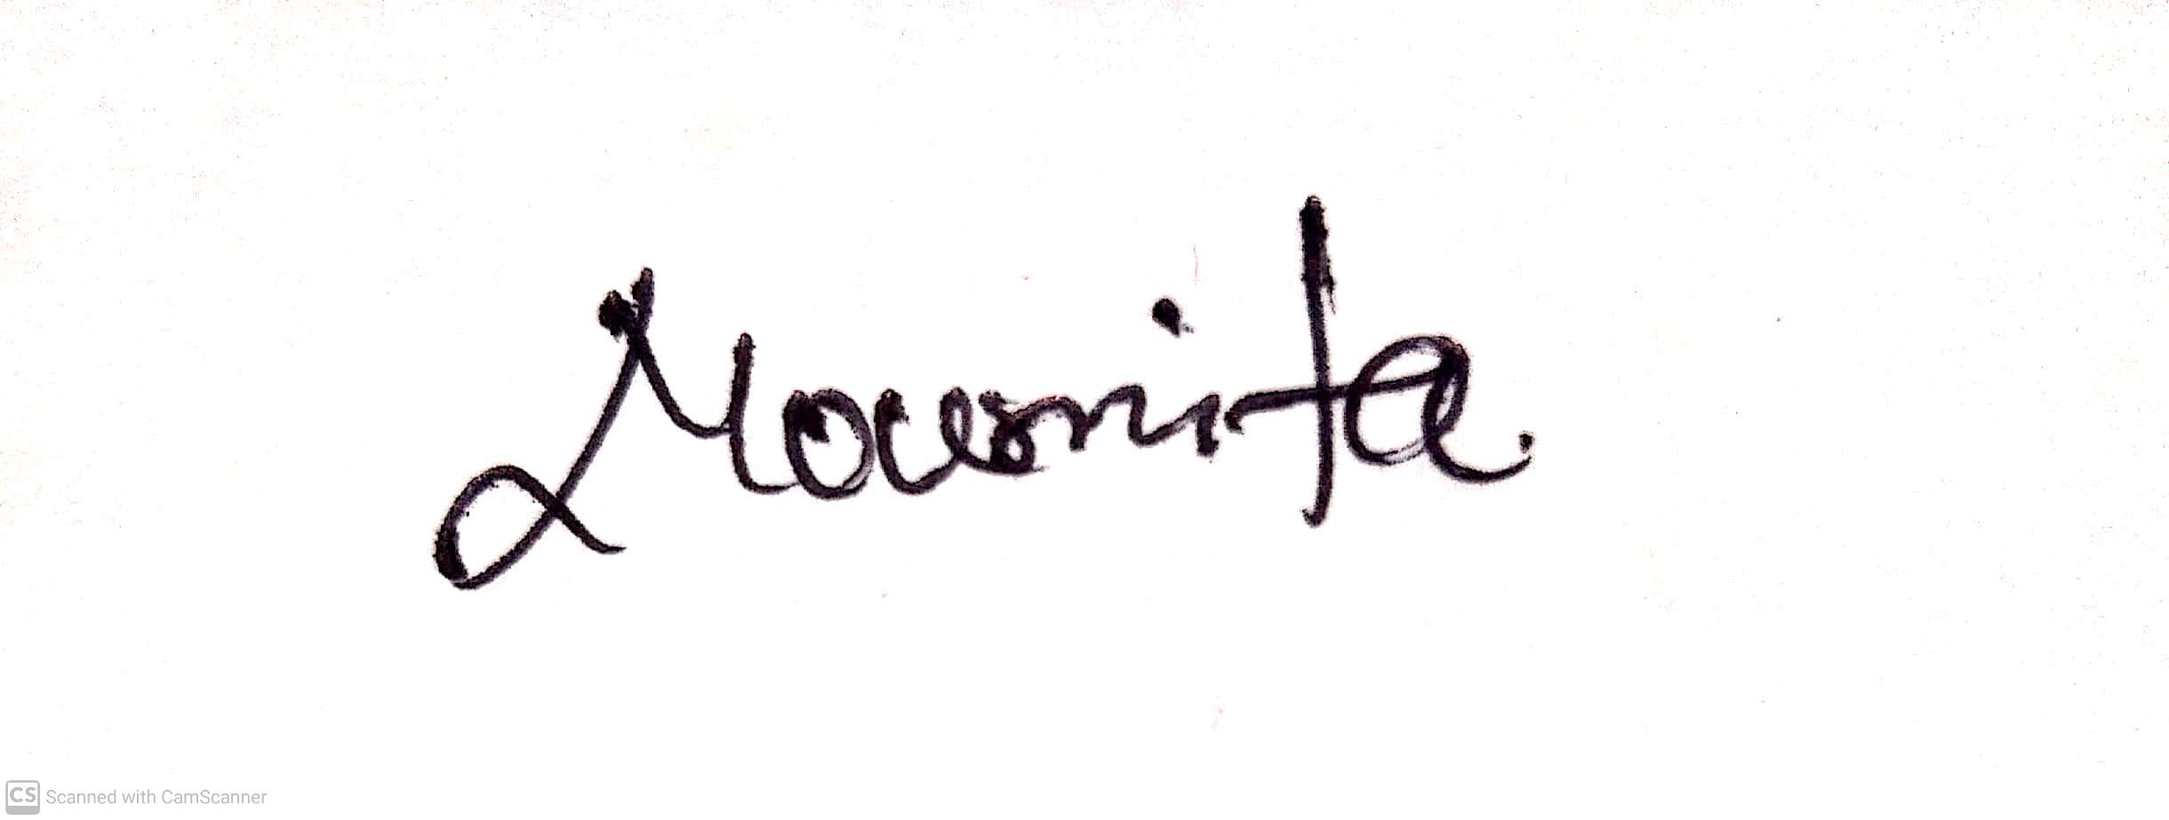______ ______15-Aug-22_____
Name Signature Date
___ Tanvir Ahammed ___ _________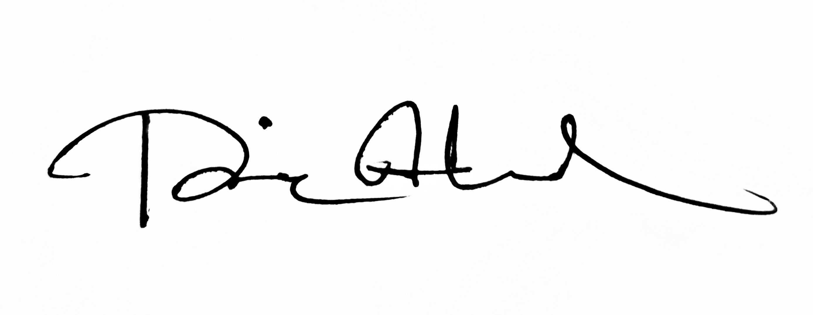______ ______15-Aug-22_____
Name Signature Date

(This form must be signed by all authors in order as appeared in the article, and should be returned to the editorial office.)

